j

Phone Selling

Webpage System

* **Faculty: Ho Hoan Kiem**
* **Batch:**
* **Team Member:**
  + - * **Hua Vinh Khang**
      * **Le Dat Anh Khoi**
      * **Nguyen Duc Trung**
      * **Dinh Nhu Hieu**

**Ho Chi Minh City, Nov 11 2020**

Table of Contents

* TITLE 1
* REVIEW 1 3

Background 4

Business Opportunity 4

Business Objectives 4

Vision Statement 4

Business Risks 4

* Hardware/ Software Requirements 6
* REVIEW 2 8
* REVIEW 3 27

REVIEW 1

Problem Definition

1. **The Object Of The Project**

### 1.1 Background

Nowadays, people find that buying products online are more convenient which leads to more and more people surf the web for buying products. We present the phone manage website to sell electronic devices to customers and manage them under the control of administrator.

### 1.2 Business Opportunity

Many phone shop owners demand a system that could help customers to order products online. Such a system can help customers to save their time and effort. The future ability for customers who want to buy electronic devices use on-web purchasing service and provide the possibility of convenience when the system is promised to cooperate with many online banking companies.

### 1.3 Business Objectives

BO-01: Reduce 15% server operating cost

BO-02: The app will be used by 4% phone shops and 43000 customers in the city after 3 months initial release.

BO-03: The app will be used by 18% phone shops and 102,000 customers in the city after 6 months initial release.

BO-04: The app will be used by 25% phone shops and 176,000 customers in the city after 1-year initial release.

### 1.4 Vision Statement

For customers who want to buy electronic devices without going directly to phone shop before this app was deployed, the Phone Selling Webpage is an Internet-based and web-enabled application that will help customers to purchase phone shop’s products online.

For shop managers who want to easily manage products and track orders in history, using the PSWS is one of the most convenient ways to implement the former demands. Unlike the paper way, with PSWS the system is real-time based which means the information is always up-to-date and the data is transparent to the managers.

### 1.5 Business Risks

RI-01: Too few phone shops and customers might use this system, affect the revenue and the investment of the system (Probability = 0.35; Impact = 9)

RI-02: The latency of the services provided to customers (Probability = 0.2; Impact = 4)

RI-03: The competition with other system providers (Probability = 0.3; Impact = 3)

Customer Request   
 Specification

1. **Functional Requirements**

Following is a list of functionalities of the system. More functionalities that you find appropriate can be added to this list.

* Customer must have a valid User Id and password to login to the system
* The default role is “Guest”. Guests can view the list of items, search items and view the detail of one of the items.
* If user want to buy products, he/she has to login as a “Customer”.
* When User want to buy products, if this is the first product to add to cart, customer has to input the address that will be the destination to ship the products. If the customer currently has a cart in session, he/she doesn’t have to input address again.
* Customer can manage his/her cart as long as the session currently exist (add more products, update the quantity, remove products and confirm the cart to make it ready to ship).
* Customer can see orders that have been confirmed to track his/her orders.
* If User login as “Admin” he/she will have the permission to add phones/ update phones and track all orders confirmed before.
* When updating phones, “Admin” can update the “Status” to “Available” or “Unavailable” to turn the View of the desire phones to “Customer” and “Guest” off. We don’t have a delete function to make sure the phones sold still exist in the database.

# Hardware/ Software Requirements

By adding new technologies such as ASP.NET 3.5, AJAX, Web Service and 3-tier architecture, the web site becomes more interactive with users, security and easily updated.

1. **System Requirement**

* **For Users**
  + **Hardware**
    - CPU: Pentium IV 2.0 GHz or higher
    - RAM: 512 MB or higher
  + **Software**
    - OS: Windows 7/8/10/XP Professional…
    - Browser: Internet Explorer 8.0 or higher, Google Chrome, Firefox, Edge, …
* **For Software Developers**
  + **Hardware**
    - CPU: Pentium IV 2.0 GHz or higher
    - RAM: 512 MB or higher
  + **Software**
    - OS: Windows 10
    - Environment: Microsoft .NET Framework 4.7.2.
    - Database Management System: Microsoft SQL Server 2014
    - IDE: Microsoft Visual Studio 2019
    - Web Server: Internet Information Services (IIS) JSP

|  |  |  |
| --- | --- | --- |
| **Date: Nov 11, 2020** | **Prepared by Project Group 3**  **Team Leader: Hua Vinh Khang** | **Approved by**  **Mr. Ho Hoan Kiem** |
| **Signature** |  |  |

REVIEW 2

**USE CASE DIAGRAM**

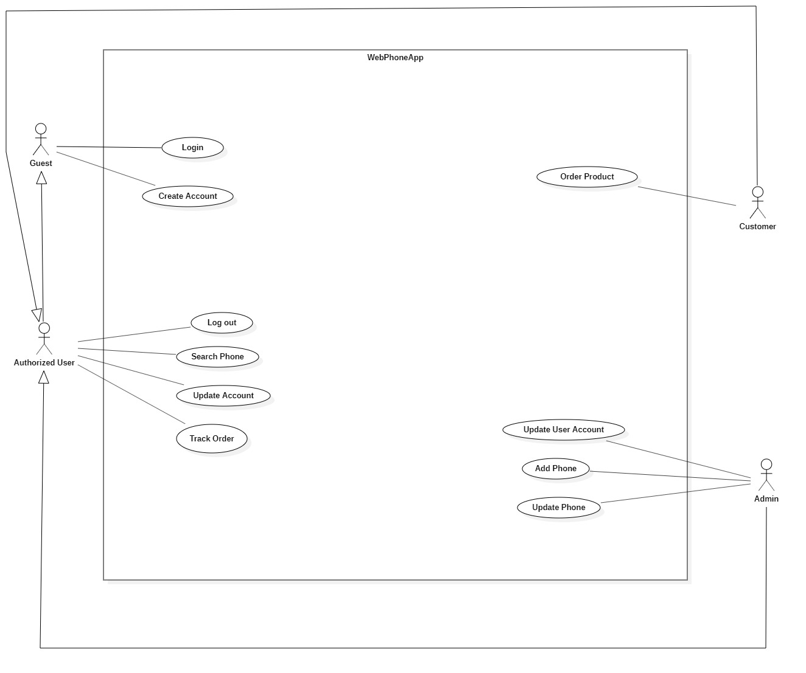

**USE CASE DESCRIPTION**

1. **Actor:**

* **Customers:** A customer is the one who will order products from the PSWS. Customers are expected to use the PSWS an average of 4 times per month each. An estimated 100 percent of orders will be placed from home or by web application
* **Administrators:** The Administrator is a shop employee who will manage all the products for the phone shop system

1. **Use case details:**

|  |  |  |  |
| --- | --- | --- | --- |
| UC ID and Name: | UC-1 Update Phone Use case | | |
| Created By: | HieuDN | Date Created: | 7-11-2020 |
| Primary Actor: | Admin | Secondary Actors: | PSWS |
| Trigger: | User clicks “Edit” button | | |
| Description: | User can update phones of the system for customer to read. | | |
| Preconditions: | PRE-1: User is logged into the PSWS as an Admin  PRE-2: User is in the detail page of the desire phone to update | | |
| Postconditions: | POST-1: The Phones updated will be stored the database with new attributes | | |
| Normal Flow: | 1. System displays a form to update phone for manager  2. Admin inputs all fields  3. Admin clicks “Update” button  4. System updates the phones that contains all the parameters admin provided before  5. System redirects user to “Detail” page | | |
| Alternative Flows: | **1.1 Admin inputs wrong format of the phone**  1. System shows the correspond message of the incorrect fields in step 2 of normal flow  2. Return to step 1 of normal flow | | |
| Exceptions: | 1. **E1 Server crash or session time-out**   1. The website redirect to the error page with “localhost refused to connect” message | | |
| Priority: | Low | | |
| Frequency of Use: | Rarely use, only if admin wants to update phones to set the price, the status, … | | |
| Business Rules: | BR-3 | | |
| Other Information: | N/A | | |
| Assumptions: | Assume that the database connection when updating has no exception | | |

|  |  |  |  |
| --- | --- | --- | --- |
| UC ID and Name: | UC-2 Add Product Use case | | |
| Created By: | HieuDN | Date Created: | 7-11-2020 |
| Primary Actor: | Admin | Secondary Actors: | PSWS |
| Trigger: | User clicks “Create Phone” button | | |
| Description: | User can add phones into the system for customer to buy | | |
| Preconditions: | PRE-1: User is logged into the PSWS as an Admin | | |
| Postconditions: | POST-1: The Phone posted will be stored in PSWS with the status “available” | | |
| Normal Flow: | 1. System displays a form to add product for admin  2. Admin inputs all fields  3. Admin clicks “Create” button  4. System stores the phone that contains all the parameters admin provided before  5. System redirects User to main page | | |
| Alternative Flows: | **2.1 Admin inputs wrong format of the products**  1. System shows the correspond message of the incorrect fields in step 2 of normal flow  2. Return to step 1 of normal flow | | |
| Exceptions: | 1. **E1 Server crash or session time-out**   1. The website redirect to the error page with “localhost refused to connect” message | | |
| Priority: | Low | | |
| Frequency of Use: | Sometimes, when admin wants to sell more phone | | |
| Business Rules: | BR-3 | | |
| Other Information: | N/A | | |
| Assumptions: | Assume that the database connection when adding has no exception | | |

|  |  |  |  |
| --- | --- | --- | --- |
| UC ID and Name: | UC-3 Search Products Use case | | |
| Created By: | HieuDN | Date Created: | 7-11-2020 |
| Primary Actor: | All Users | Secondary Actors: | PSWS |
| Trigger: | User clicks “Search Phone” button | | |
| Description: | User can view the list phones of the system through search keywords | | |
| Preconditions: | PRE-1: User is in the main page that shows phone list | | |
| Postconditions: | POST-1: The Phone list is showed to user | | |
| Normal Flow: | 1. User inputs search field  2. User clicks “Search” button  3. System shows the list of Phones that contains the keywords user provided before | | |
| Alternative Flows: | **3.1 User inputs nothing on the search field**  1. System redirect user to the main page  2. Return to step 1 of normal flow | | |
| Exceptions: | **3.0 E1 Server crash or session time-out**  1. The website redirect to the error page with “localhost refused to connect” message | | |
| Priority: | High | | |
| Frequency of Use: | Highly use, when Admin wants to view Phones list to manage phone and when customer want to search phone to buy | | |
| Business Rules: | N/A | | |
| Other Information: | N/A | | |
| Assumptions: | Assume that the database connection when searching has no exception | | |

|  |  |  |  |
| --- | --- | --- | --- |
| UC ID and Name: | UC-4 Update Information Use case | | |
| Created By: | KhoiLDA | Date Created: | 7-11-2020 |
| Primary Actor: | Authorized User | Secondary Actors: | PSWS |
| Trigger: | User clicks “Update Account” button | | |
| Description: | User can update information of his/her account. Admin can update information of any Users’ account. | | |
| Preconditions: | PRE-1: User is logged into the PSWS as an Authorized User  PRE-2: User is in the detail page of their account to update | | |
| Postconditions: | POST-1: The Account Information updated will be stored in Database | | |
| Normal Flow: | 1. System displays a form to update Information for user  2. User inputs all fields  3. User clicks “Update Information” button  4. System updates the information that contains all the parameters user provided before  5. System redirect to main page. | | |
| Alternative Flows: | **4.1 User inputs wrong format of the information**  1. System shows the correspond message of the incorrect fields in step 2 of normal flow  2. Return to step 1 of normal flow | | |
| Exceptions: | **4.0E1 Server crash or session time-out**  1. The website redirect to the error page with “localhost refused to connect” message | | |
| Priority: | Low | | |
| Frequency of Use: | Usually use, only if Admin wants to update account to set the status, and when users want to change their information | | |
| Business Rules: | BR-2 | | |
| Other Information: | N/A | | |
| Assumptions: | Assume that the database connection when updating has no exception | | |

|  |  |  |  |
| --- | --- | --- | --- |
| UC ID and Name: | UC-5 – Order products | | |
| Created By: | KhangHV | Date Created: | 7-11-2020 |
| Primary Actor: | Customer | Secondary Actors: | PSWS |
| Trigger: | Customer clicks “Confirm Payment” button | | |
| Description: | Customer order the products that they want from PSWS | | |
| Preconditions: | PRE-1. Customer is logged into PSWS  PRE-2. Customer has added products to cart  PRE-3. Customer is in the “View Cart” page | | |
| Postconditions: | POST-1. Order is stored in PSWS | | |
| Normal Flow: | **5.0. Order products**  1. PSWS displays a show cart that contains all the products in cart, the total cost that customer must pay and a button to confirm their order  2. Customer confirm their order  3. PSWS stores order, sends order information to PSWS  4. System show notification for customer if the order has been submitted successfully | | |
| Alternative Flows: | None | | |
| Exceptions: | **5.0 E1 Product is order has recently out of stock**  1. PSWS informs the product that has out of stock  **5.1 E1 Server crash or session time-out**  1. The website redirect to the error page with “localhost refused to connect” message | | |
| Priority: | High | | |
| Frequency of Use: | Approximately 200 users, average of one usage per day. | | |
| Business Rules: | BR-1 | | |
| Other Information: | Customer shall be able to order at any time if they have selected the item | | |
| Assumptions: | Assume that the database connection when updating has no exception | | |

|  |  |  |  |
| --- | --- | --- | --- |
| UC ID and Name: | UC-6 – Track Orders | | |
| Created By: | TrungND | Date Created: | 7-11-2020 |
| Primary Actor: | Authorized User | Secondary Actors: | PSWS |
| Trigger: | User clicks “Manage Order” button as an Admin or “View Order” as a Customer. | | |
| Description: | Customer can see orders that he/she has confirmed before and Admin can track all orders have been confirmed. | | |
| Preconditions: | PRE-1. User is logged into PSWS as “Customer” or “Admin”  PRE-2. User is in the main page  PRE-3. After access the Order List page, user can click an order to view the order details. | | |
| Postconditions: | POST-1. Order information and details is shown to User | | |
| Normal Flow: | **6.0. Order products**  1. PSWS displays a list of orders that Customers have confirmed before to Admin or displays a list of orders of a Customer to him/herself  2. Customer clicks “Check” button / Admin clicks an Order  3. PSWS shows the list of Order Details for User | | |
| Alternative Flows: | None | | |
| Exceptions: | **6.0 E1 Server crash or session time-out**  1. The website redirect to the error page with “localhost refused to connect” message | | |
| Priority: | Medium | | |
| Frequency of Use: | Approximately 50 users, average of one usage per day. When Customer wants to check his/her orders and Admin wants to track orders. | | |
| Business Rules: | BR-4 | | |
| Other Information: | N/A | | |
| Assumptions: | Assume that the database connection when tracking has no exception | | |

|  |  |  |  |  |
| --- | --- | --- | --- | --- |
| ID | Rule Definition | Type of Rule | Static or Dynamic | Source |
| BR-1 | Only Customers can use the order products function | Constraint | Static | Phone Shop Manager |
| BR-2 | Only Admin can modify other users. | Constraint | Static | Phone Shop Manager |
| BR-3 | Only Admin can create, modify or delete products. | Constraint | Static | Phone Shop Manager |
| BR-4 | Only show Customer own Orders if a User is logged as a Customer. | Constraint | Static | Phone Shop’s Policy |

**Business Rules:**

**SYSTEM ARCHITECTURE**

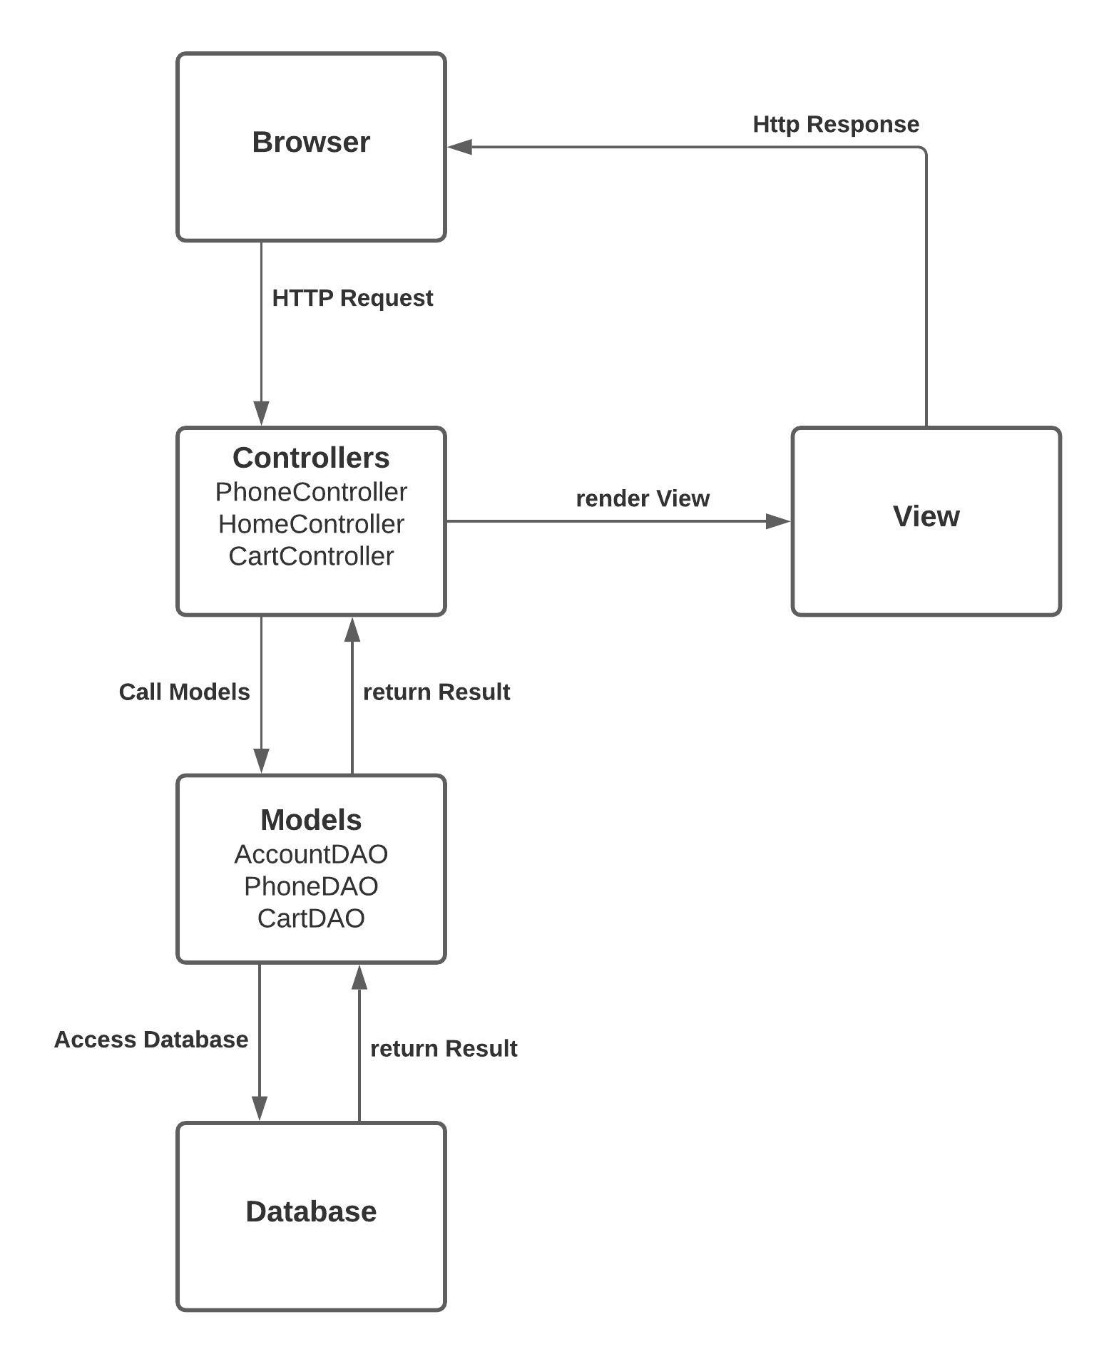

**CLASS DIAGRAM**

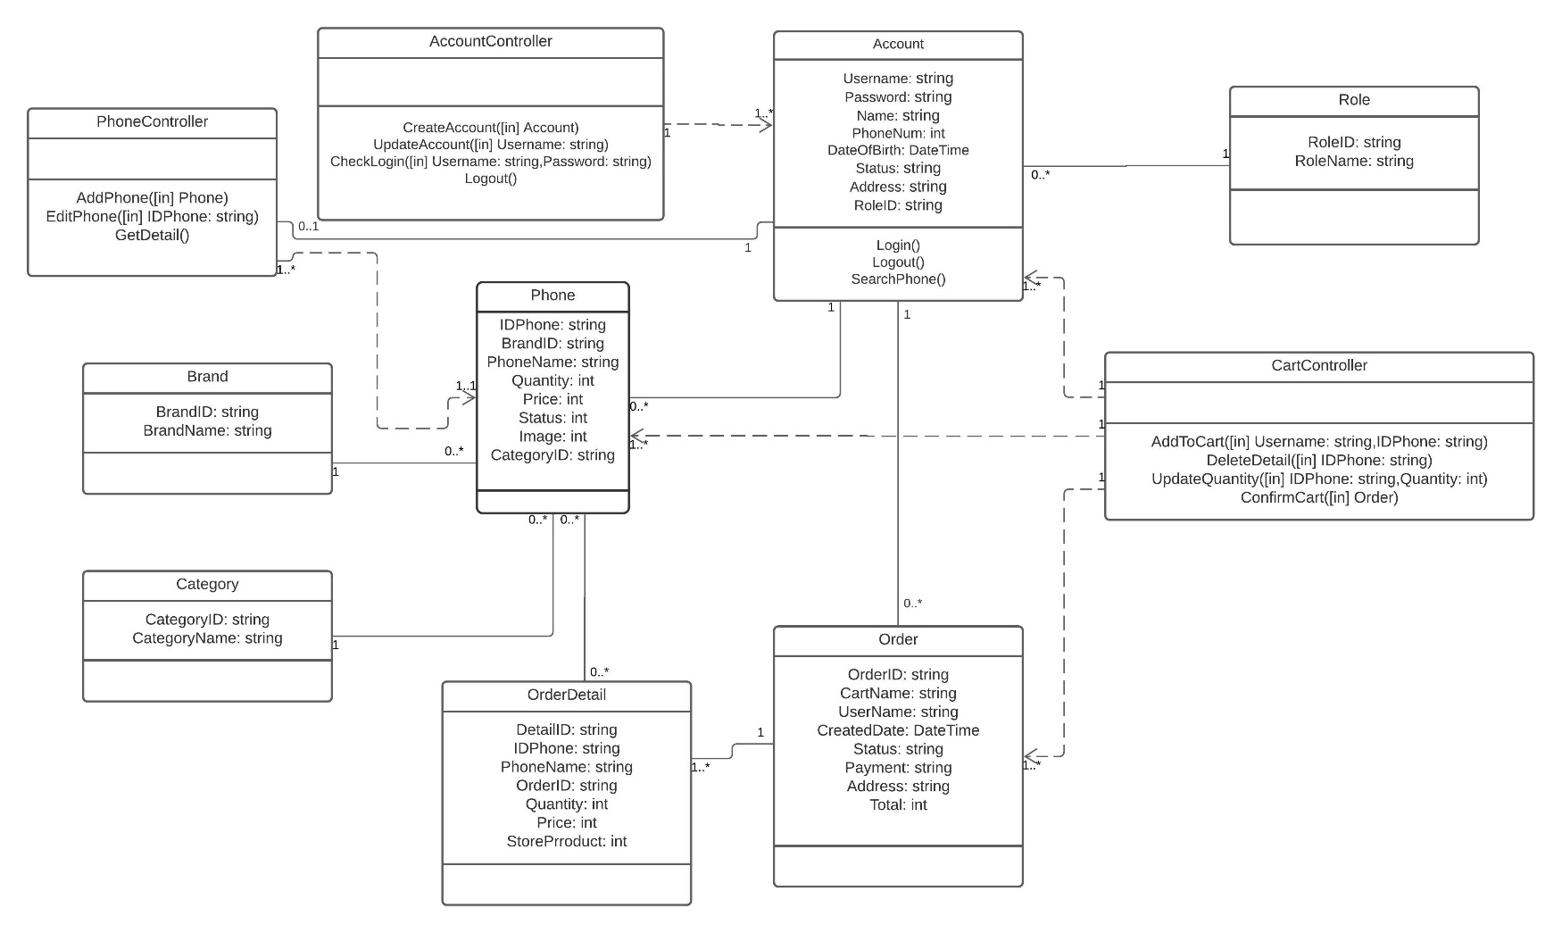

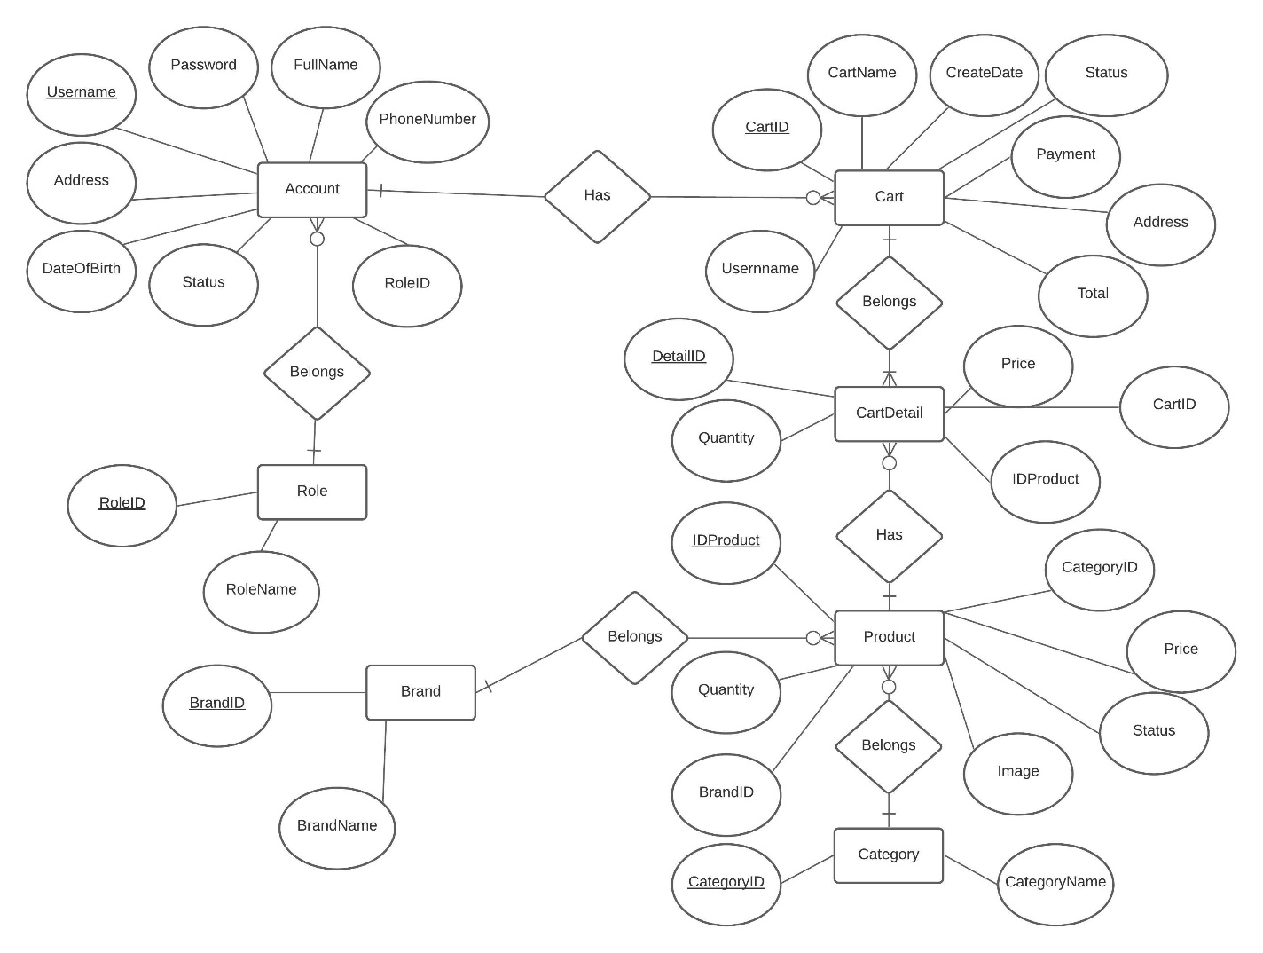**ENTITY RELATIONSHIP DIAGRAM (ERD)**  
 **ENTITY DESCRIPTION**

One to  
 zero - many relationship

Entity

Entity Relationship

One to  
 one - many relationship

Contain

**1.Account:**

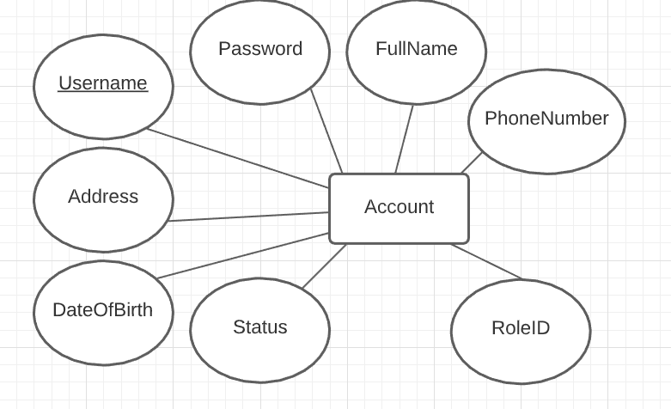

**2. Role:**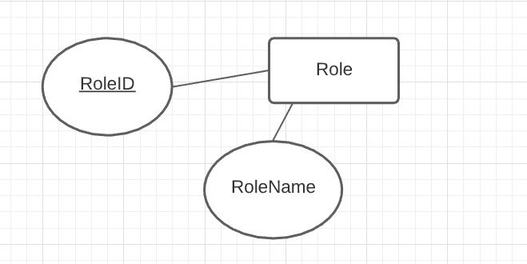

**3. Brand :**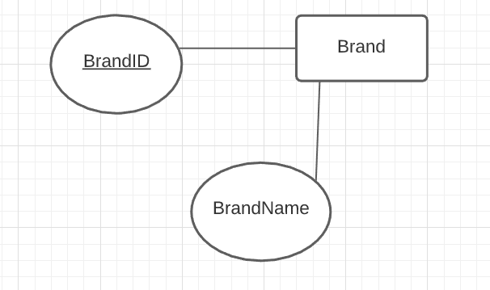

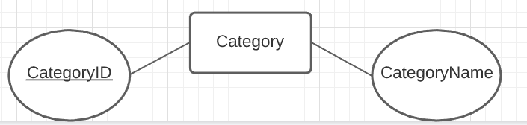**4. Category:**

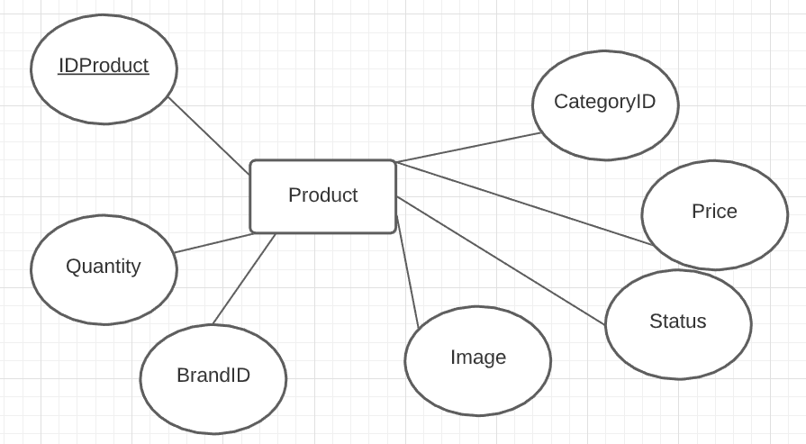**5. Product:**

**6. Cart:**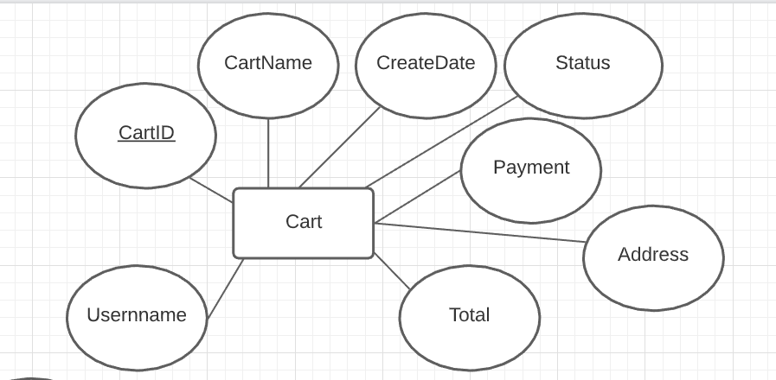

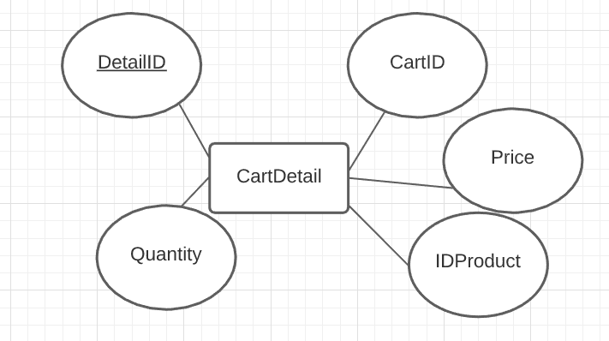**7. Cart Detail:**

**TABLE DESIGN**

**1.Account:**

|  |  |  |  |  |
| --- | --- | --- | --- | --- |
| Data Element | Description | Composition or Data Type | Length | Values |
| **🗝** Username | The Username of a customer, customer can use this Username goes with Password to access the System | String | 20 |  |
| Password | The Password of a customer, he/she can use the Password goes with Username to access the System | String | 20 |  |
| PhoneNumber | The phone number of a customer, customer can use this phone number to order products from the shop | String | 11 | A string of numbers that can be 10 to 11 characters |
| FullName | Full Name of a customer | Alphabetic | 50 |  |
| Address | Address of a customer, can be the address to ship product | String | 200 |  |
| DateOfBirth | Date of birth of a customer | Date, MM/DD/YYYY | 10 |  |
| Status | Status of an account (Available/ Banned) | String | 9 |  |
| RoleID | ID of a role of a User | String | 5 | A string of numbers |

**2. Role:**

|  |  |  |  |  |
| --- | --- | --- | --- | --- |
| Data Element | Description | Composition or Data Type | Length | Values |
| **🗝** RoleID | ID of a role of a User | String | 5 | A string of numbers |
| RoleName | Name of a role of a User | String | 15 | Customer/ Admin |

**3. Brand :**

|  |  |  |  |  |
| --- | --- | --- | --- | --- |
| Data Element | Description | Composition or Data Type | Length | Values |
| **🗝** BrandID | The ID of a product brand | String | 5 | A numeric string |
| BrandName | The name of a product brand | String | 50 |  |

**4. Category:**

|  |  |  |  |  |
| --- | --- | --- | --- | --- |
| Data Element | Description | Composition or Data Type | Length | Values |
| **🗝** CategoryID | The ID of a product category | String | 5 | A numeric string |
| CategoryName | The name of a product category | String | 50 |  |

**5. Product:**

|  |  |  |  |  |
| --- | --- | --- | --- | --- |
| Data Element | Description | Composition or Data Type | Length | Values |
| **🗝** IDProduct | The ID of a product | String | 5 | A numeric string |
| ProductName | The name of a product | String | 50 |  |
| Quantity | The quantity of a product in storage | Integer | 7 | A positive integer |
| Price | The price of a product | Integer | 10 | A positive integer in VND |
| Status | The status of a product | String | 20 | Available / Unavailable |
| Image | The image of a product | String | 500 | A hyperlink of the image of a product |
| CategoryID | The ID of a product category | String | 5 | A numeric string |

**6. Cart:**

|  |  |  |  |  |
| --- | --- | --- | --- | --- |
| Data Element | Description | Composition or Data Type | Length | Values |
| **🗝** CartID | The ID of an order that from customer to order products | String | 5 | A string of numbers |
| CartName | Name of an order | String | 50 |  |
| CreatedDate | Date generated when customer creates the order | Date, MM/DD/YYYY | 10 |  |
| Address | Address of a customer, can be the address to ship products | String | 200 |  |
| Username | Username of customer who has the cart | String | 20 |  |
| Status | Status of an order | String | 20 | Waiting /Pending /Cancelled/ Done |
| Payment | Payment of the order | String | 10 | COD (currently) |
| Total | Total price of all products | Integer | 10 | Positive Integer in VND |

**7. Cart Detail:**

|  |  |  |  |  |
| --- | --- | --- | --- | --- |
| Data Element | Description | Composition or Data Type | Length | Values |
| **🗝** DetailID | The ID of an order detail that from a customer-order’s list to order products | String | 5 | A string of numbers |
| CartID | The ID of an order that from customer to order products | String | 5 | A string of numbers |
| Price | The price of a product that is in an order detail (for storing data purpose) | Integer | 10 | A positive integer in VND |
| Quantity | The quantity of a product that is in the order detail | Integer | 3 | A positive integer |
| IDProduct | The ID of a product | String | 5 | A numeric string |

**Note**

**🗝** Primary key

✓ Unique constraint

**TABLE RELATIONSHIP DIAGRAM**

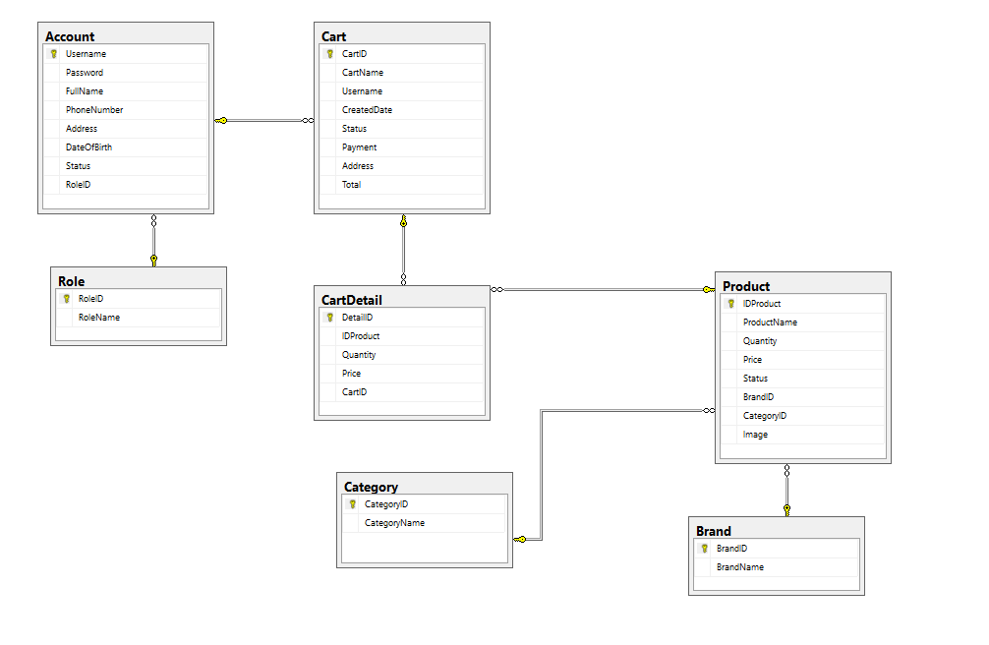

|  |  |  |
| --- | --- | --- |
| **Date: Nov 11, 2020** | **Prepared by Project Group 3**  **Team Leader: Hua Vinh Khang** | **Approved by**  **Mr. Ho Hoan Kiem** |
| **Signature** |  |  |

REVIEW 3

**INTERFACE DESIGN**

1. 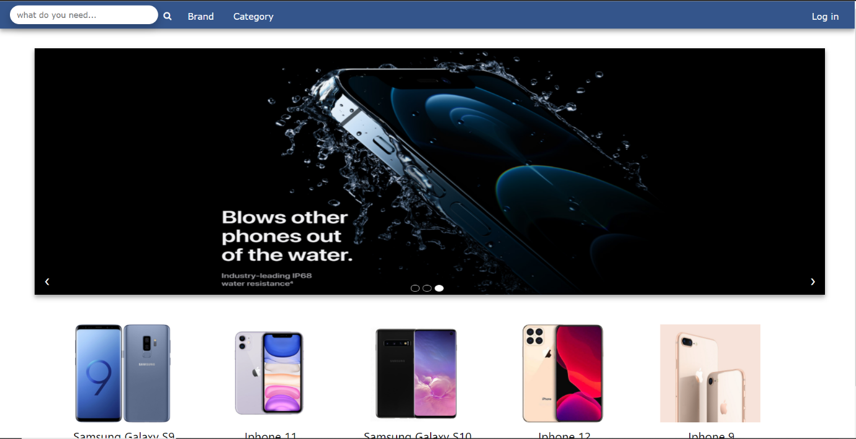**Home Page (Guest)**

|  |  |  |  |  |  |
| --- | --- | --- | --- | --- | --- |
| **Name** | **Type** | **Event** | **Validation** | **Description** | **Status** |
| Search | TextBox |  | String | Input Product’s name |  |
| Button Search | Button |  | Click | Search products with text in Search Text Box to list in home page. |  |
| Log in | Button |  | Click | Choose Login |  |
| Brand | Dropdown Button |  | Click | Choose a brand of products. |  |
| Category | Dropdown Button |  | Click | Choose a type of products. |  |

1. **Product’s Details (Guest)**

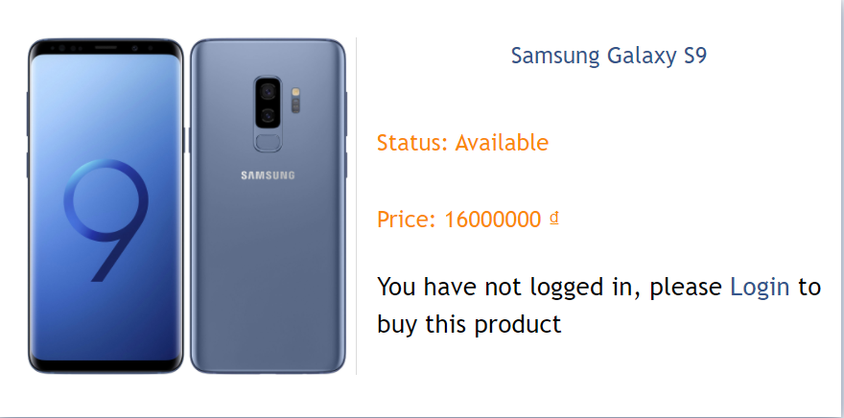

|  |  |  |  |  |  |
| --- | --- | --- | --- | --- | --- |
| **Name** | **Type** | **Event** | **Validation** | **Description** | **Status** |
| Login | Button |  | Click | Login to buy this product |  |

1. **Login**



|  |  |  |  |  |  |
| --- | --- | --- | --- | --- | --- |
| **Name** | **Type** | **Event** | **Validation** | **Description** | **Status** |
| Username | TextBox |  | String, not null | Input username |  |
| Password | TextBox |  | String, not null | Input password |  |
| Submit | Button |  | Click | Choose Submit to enter with authorized user. |  |
| Register | Button |  | Click | Choose Register a new customer account. |  |

1. **Register**

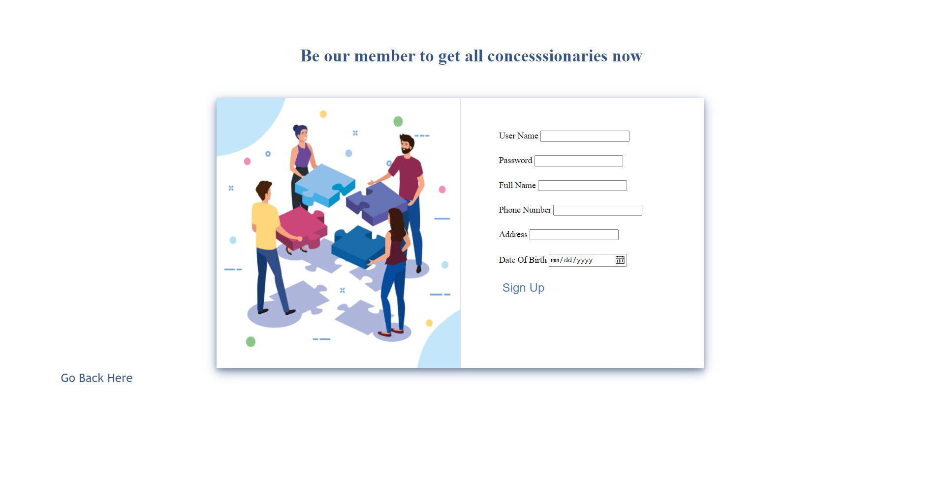

|  |  |  |  |  |  |
| --- | --- | --- | --- | --- | --- |
| **Name** | **Type** | **Event** | **Validation** | **Description** | **Status** |
| Username | TextBox |  | String, not null | Input username |  |
| Password | TextBox |  | String, not null | Input password |  |
| Fullname | TextBox |  | String, not null | Input Fullname |  |
| Phone Number | TextBox |  | String, not null | Input Phone Number |  |
| Address | TextBox |  | String, not null | Input Address |  |
| Date of Birth | Date |  | Click | Input Birthday |  |
| Sign Up | Button |  | Click | Choose Sign up |  |
| Go Back Here | Button |  | Click | Choose Go back here to go to Login Page |  |

1. **Nav bar (Customer)**



|  |  |  |  |  |  |
| --- | --- | --- | --- | --- | --- |
| **Name** | **Type** | **Event** | **Validation** | **Description** | **Status** |
| Search | TextBox |  | String | Input Product’s name |  |
| Button Search | Button |  | Click | Search products with text in Search Text Box to list in home page. |  |
| Log out | Button |  | Click | Choose Log out account |  |
| Brand | Dropdown Button |  | Click | Choose a brand of products. |  |
| Category | Dropdown Button |  | Click | Choose a type of products. |  |
| Your Cart | Button |  | Click | Choose “Your cart” |  |
| Your Orders | Button |  | Click | Choose “Your Orders” |  |

1. **Product’s Details**

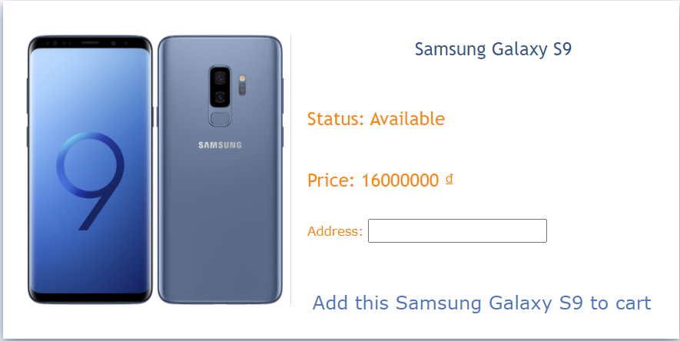

|  |  |  |  |  |  |
| --- | --- | --- | --- | --- | --- |
| **Name** | **Type** | **Event** | **Validation** | **Description** | **Status** |
| Address | TextBox |  | String, not null | Input Address |  |
| Add this “product” to cart | Button |  | Click | Add this product is choosing into cart |  |

1. **View Cart**

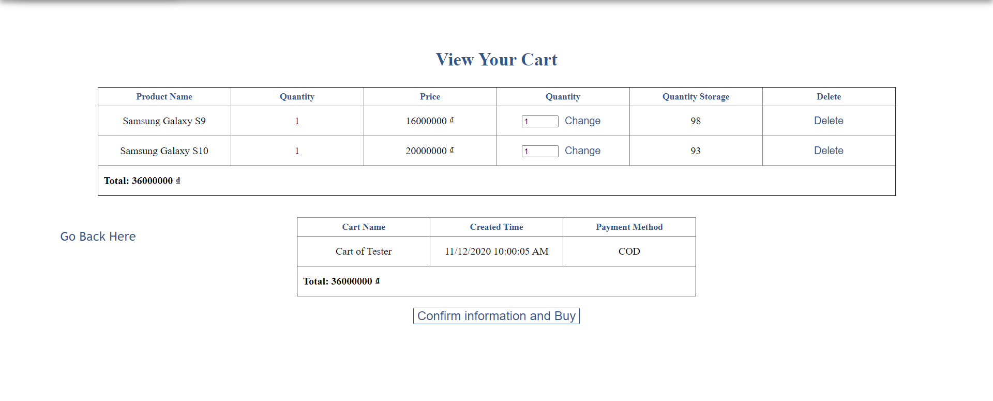

|  |  |  |  |  |  |
| --- | --- | --- | --- | --- | --- |
| **Name** | **Type** | **Event** | **Validation** | **Description** | **Status** |
| Quantity | Number |  | int, not null | Input number to update quantity of product. |  |
| Change | Button |  | Click | Change quantity of product. |  |
| Delete | Button |  | Click | Delete this product from cart. |  |
| Confirm information and Buy | Button |  | Click | Confirm this cart and add order to database. |  |
| Go Back Here | Button |  | Click | Choose Go back here to go to Home Page |  |

1. **View Order**

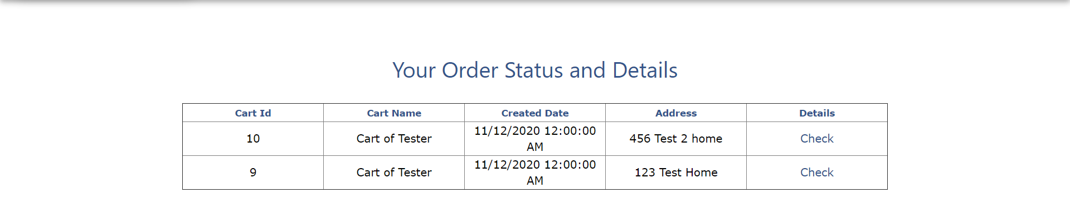

|  |  |  |  |  |  |
| --- | --- | --- | --- | --- | --- |
| **Name** | **Type** | **Event** | **Validation** | **Description** | **Status** |
| Check | Button |  | Click | Check Details of this order. |  |

1. **Nav Bar (Admin)**



|  |  |  |  |  |  |
| --- | --- | --- | --- | --- | --- |
| **Name** | **Type** | **Event** | **Validation** | **Description** | **Status** |
| Search | TextBox |  | String | Input Product’s name |  |
| Button Search | Button |  | Click | Search products with text in Search Text Box to list in home page. |  |
| Log out | Button |  | Click | Choose Log out account |  |
| Brand | Dropdown Button |  | Click | Choose a brand of products. |  |
| Category | Dropdown Button |  | Click | Choose a type of products. |  |
| Manage Order | Button |  | Click | Choose “Manage Order” |  |
| Create Phone | Button |  | Click | Choose “Create Phone” |  |
| Manage Account | Button |  | Click | Choose “Manage Account” |  |

1. **Product’s Details (Admin)**

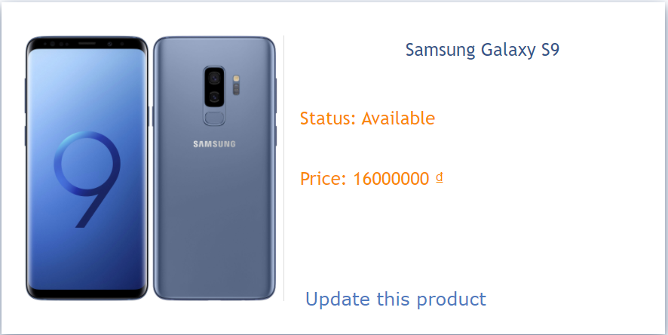

|  |  |  |  |  |  |
| --- | --- | --- | --- | --- | --- |
| **Name** | **Type** | **Event** | **Validation** | **Description** | **Status** |
| Update this product | Button |  | Click | Choose “Update this product” |  |

1. **Update Product**

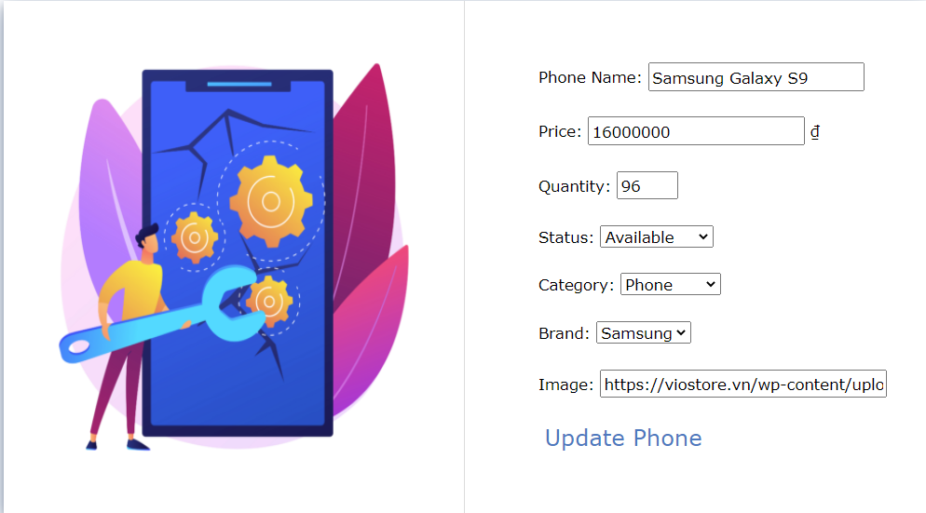

|  |  |  |  |  |  |
| --- | --- | --- | --- | --- | --- |
| **Name** | **Type** | **Event** | **Validation** | **Description** | **Status** |
| Phone Name | TextBox |  | String, not null | Input Product’s name |  |
| Price | Number |  | Int, not null | Input Product’s Price |  |
| Quantity | Number |  | Int, not null | Input Product’s Quantity |  |
| Status | Dropdown Button |  | Click | Choose a Status of products. |  |
| Category | Dropdown Button |  | Click | Choose a Type of products. |  |
| Brand | Dropdown Button |  | Click | Choose a Brand of products. |  |
| Image | TextBox |  | String, not null | Input Product’s Image Link |  |
| Update Phone | Button |  | Click | Choose “Update Phone” |  |
| Go Back | Button |  | Click | Choose “Go back” |  |

1. **Create Product**

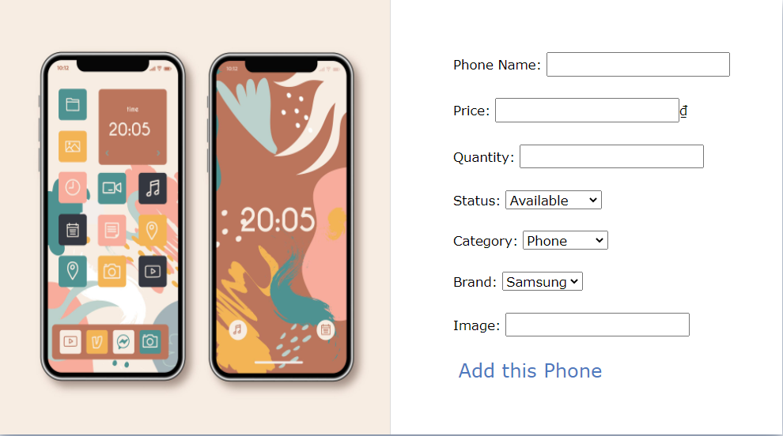

|  |  |  |  |  |  |
| --- | --- | --- | --- | --- | --- |
| **Name** | **Type** | **Event** | **Validation** | **Description** | **Status** |
| Phone Name | TextBox |  | String, not null | Input Product’s name |  |
| Price | Number |  | Int, not null | Input Product’s Price |  |
| Quantity | Number |  | Int, not null | Input Product’s Quantity |  |
| Status | Dropdown Button |  | Click | Choose a Status of products. |  |
| Category | Dropdown Button |  | Click | Choose a Type of products. |  |
| Brand | Dropdown Button |  | Click | Choose a Brand of products. |  |
| Image | TextBox |  | String, not null | Input Product’s Image Link |  |
| Add this Phone | Button |  | Click | Choose “Add this Phone” |  |

1. **Manage Account**

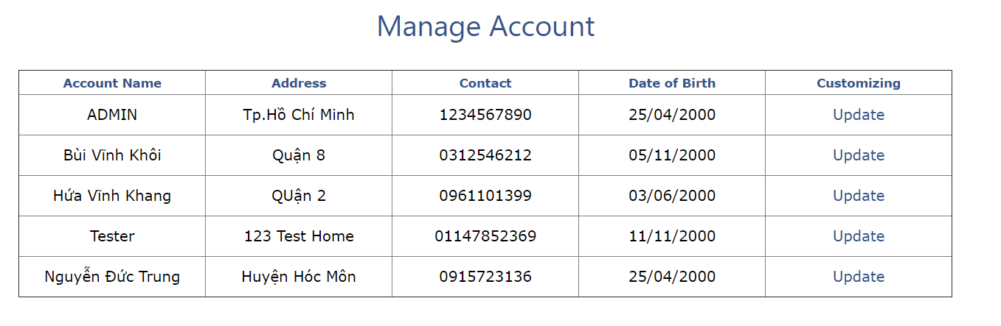

|  |  |  |  |  |  |
| --- | --- | --- | --- | --- | --- |
| **Name** | **Type** | **Event** | **Validation** | **Description** | **Status** |
| Update | Button |  | Click | Choose “Update this account” |  |

1. **Account’s Details**

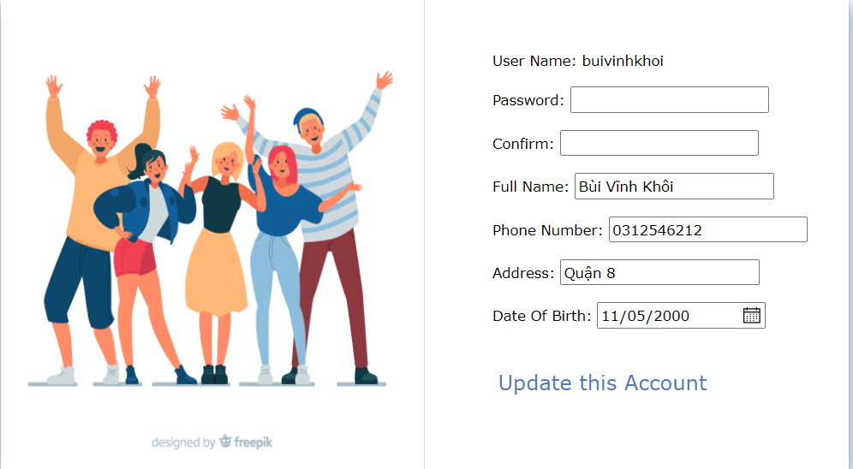

|  |  |  |  |  |  |
| --- | --- | --- | --- | --- | --- |
| **Name** | **Type** | **Event** | **Validation** | **Description** | **Status** |
| Username | TextBox |  | String, not null | Input username |  |
| Password | TextBox |  | String, not null | Input password |  |
| Fullname | TextBox |  | String, not null | Input Fullname |  |
| Phone Number | TextBox |  | String, not null | Input Phone Number |  |
| Address | TextBox |  | String, not null | Input Address |  |
| Date of Birth | Date |  | Click | Input Birthday |  |
| Update this Account | Button |  | Click | Choose “Update this Account” |  |

1. **Manage Order**

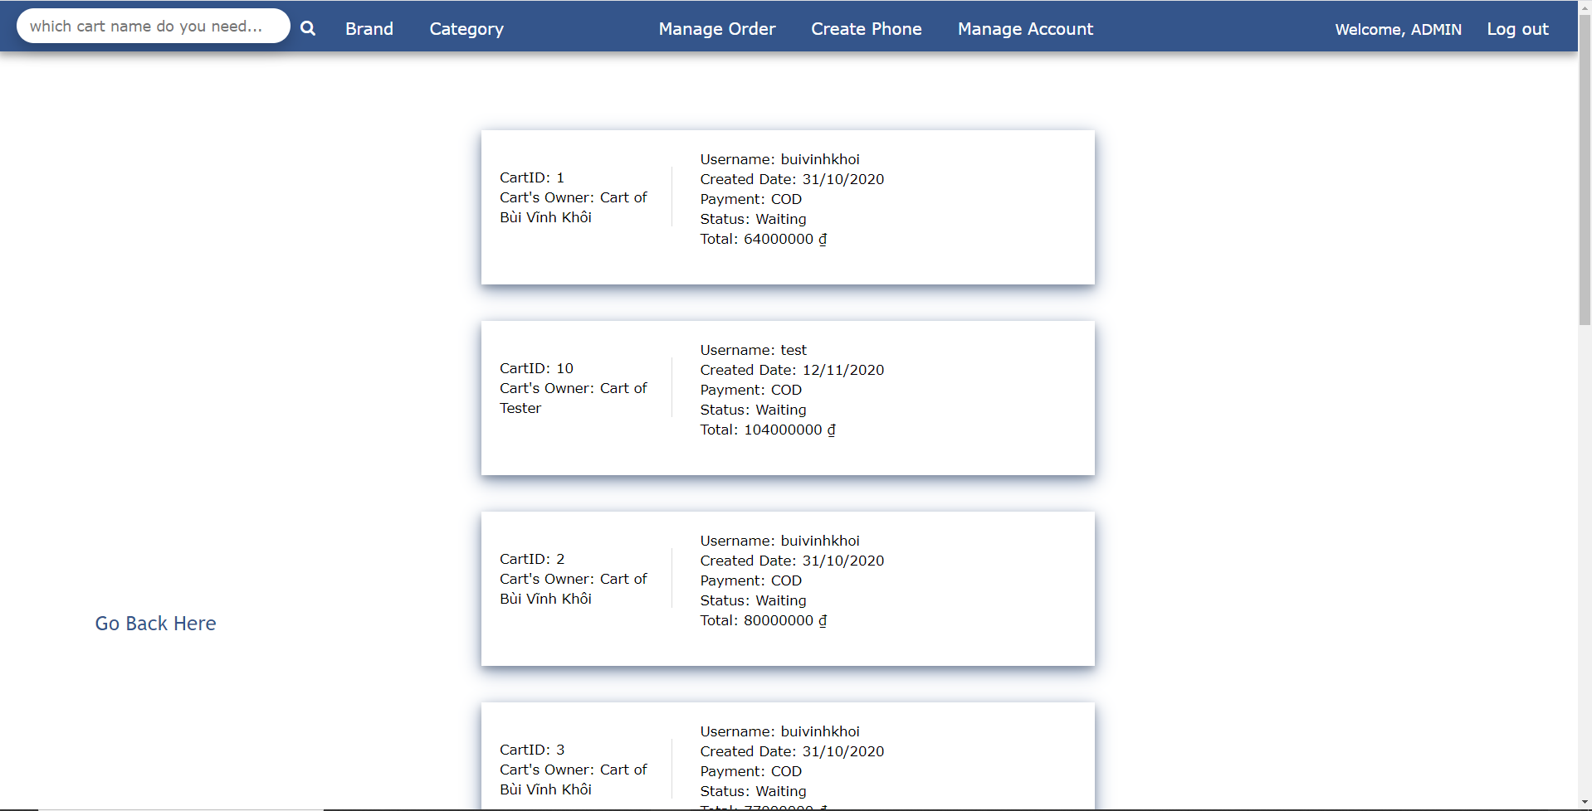

|  |  |  |  |  |  |
| --- | --- | --- | --- | --- | --- |
| **Name** | **Type** | **Event** | **Validation** | **Description** | **Status** |
| Order Detail | Button |  | Click | Choose an order to manage order details in this order. |  |
| Go Back Here | Button |  | Click | Choose “Go Back Here” to go to Home page |  |
| Search | Textbox |  | String | Input Cart’s name |  |
| Button Search | Button |  | Click | Search Cart with text in Search Textbox in the Order Manage Page of Admin |  |

**TASK SHEET**

|  |  |  |  |  |  |  |
| --- | --- | --- | --- | --- | --- | --- |
| **Project Group** | | **Project Title**  **Phone Selling Webpage System** | | **Date of Preparation** | | **Activity Plan Prepared by**  **Nguyen Duc Trung** |
| **No** | **Task Title** | | **Planned Start Date** | **Planned Completed Date** | **Team Mate Names** | **Status** |
| 1 | Create Product | | Oct 19, 2020 | Nov 10, 2020 | Dinh Nhu Hieu | Done |
| 2 | Update Product | | Done |
| 3 | Disable Product | | Done |
| 4 | Search Product | | Done |
| 5 | User interface | | Done |
| 6 | Retrieve Product List | | Hua Vinh Khang | Done |
| 7 | Add Cart Detail | | Done |
| 8 | Update Cart Detail | | Done |
| 9 | Remove Cart Detail | | Done |
| 10 | See Cart Detail | | Done |
| 11 | Login from Customers and Admin | | Done |
| 12 | Find Product by Category | | Nguyen Duc Trung | Done |
| 13 | Find Product by Name | | Done |
| 14 | Find Product by Brand | | Done |
| 15 | Search cart name | | Done |
| 16 | Track Order | | Done |
| 17 | Validate with JS | | Le Dat Anh Khoi | Done |
| 18 | Register Account | | Done |
| 19 | Update Account | | Done |

|  |  |  |
| --- | --- | --- |
| **Date: Nov 11, 2020** | **Prepared by Project Group 3**  **Team Leader: Hua Vinh Khang** | **Approved by**  **Mr. Ho Hoan Kiem** |
| **Signature** |  |  |